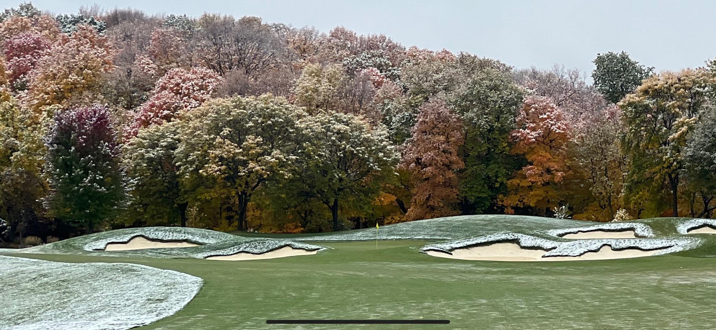
Bearpath Golf and Country Club is seeking an 2nd Assistant Superintendent to lead our Golf Course and the Turfgrass Team. The 2nd Assistant Superintendent would be joining a management team that oversees over 250 acres of turf, and grounds of the finest gated community in the state. Bearpath Golf and Country Club is in the Middle of a Golf Course renovation that is in the hands and eyes of one the greatest professional golfers in the world Jack Nicklaus. Currently in Phase 2, with Phase 1 completed with new green sites, Grass, irrigation, and bunkers along with some new tee boxes. To find out the rest of the plans and get a great opportunity to be part of a renovation along with creating something special here at Bearpath you will need to apply!!

Job Overview:

The 2nd Assistant Superintendent will be responsible for the golf course operation and maintenance. Responsibilities include, turfgrass/plant material maintenance programs, personnel management, budgeting/forecasting, scheduling and maintenance of irrigation systems, pesticide application calibrations and related recordings, create environment where staff is involved and enthusiastic, with open communications and respect for themselves, our members, guest, and the property.

Basic Functions:

- Works closely with, advises and coordinates with Golf Course Superintendent and Senior Assistant Superintendent
- Works hand in hand with Golf Course Superintendent to develop and implement an agronomic plan
- Directs and participates in the construction and maintenance of the grounds.
- Administers and enforces all Club rules, regulations and polices for staff.
- Ability to work independently and be a self-starting problem solver.
- Involved in Budget development and implementation

Primary Duties:

- Planning and carrying out day to day championship course conditions
- Provides technical, operational and safety training for employees to ensure that staff is working withing OSHA, club safety, state, and federal guidelines for safe working conditions.
- Oversees subordinates in power and safe operation, and maintenance of mechanic and power equipment.
- Supervises all application and recording of chemical applications (fertilizers and pesticides) on the Club’s grounds in compliances with all local state and federal regulations.
- Assists Clubhouse/Pool/Tennis team with maintenance issues as needed.
- Coordinates and schedules daily task/course setup
- Assists with all planning, fertilizing, and chemical applications.
- Inspects course regularly to evaluate and recommend improvements.
- Assist with development and maintenance of drainage irrigation and watering systems.
- Perform golf course maintenance task as assigned by Senior Assistant Superintendent

Requirements:

- Must be detail oriented
- Top notch communications skills
- Prior Supervisor experience a plus
- Must be willing to work Weekends, and holidays
- Must have or obtain a Minnesota Pesticide license within 90 days as well as have a Valid Driver’s license
- Must like a great work life balance.
- Must like to enjoy summers because you get a lot of opportunities with only working ONCE EVERY 4 weeks

Preferred Education:

- Associates Degree
- In a credited school attain a degree/certificate

Salary:

- $48,000-$52,000

Benefits:

- Club’s Benefit package includes
  - Health insurance
  - Participation in Bearpath’s 401K program
  - Golfing Privileges
  - Our Turfgrass team plays golf in the Men’s league
  - $1,000 Uniform budget
  - PTO
  - Holiday Bonus
  - National and Local chapter dues paid
  - Opportunity to attend local and national shows
  - Every 4th weekend in the summer to enjoy it with your family and friends
  - 4 day weeks in the shoulder seasons to refresh and refocus to be the best we can be

Date available: Immediately

Application Deadline: Open until filled.

Send resumes and cover letter to:
Jim Snell
Golf Course Superintendent
jsnell@bearpathgolf.com

